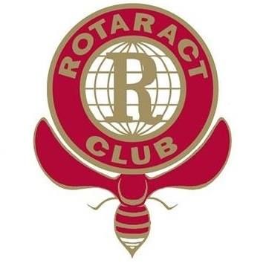

International Children’s Day was established by the United Nations General Assembly in 1954 and chosen to be the 1st of June each year. It was established to encourage all countries to institute a day, firstly to promote mutual exchange and understanding among children and secondly to initiate action to benefit and promote the welfare of the world's children. The goal is to promote the utilization of the ‘Declaration of the Rights of the Child’ for the benefit of children around the World.

Rotaract Manchester International organized this exhibition by collecting drawings from the number of orphanages and special care institutions for children in Italy, Romania and Bulgaria to point out their views of the world and standing inequality among the children.



**The Declaration of the Rights of the Child lays down ten principles:**

* 1. The right to equality, without distinction on account of race, religion or national origin.
* 2. The right to special protection for the child’s physical, mental and social development.
* 3. The right to a name and a nationality.
* 4. The right to adequate nutrition, housing and medical services.
* 5. The right to special education and treatment when a child is physically or mentally handicapped.
* 6. The right to understanding and love by parents and society.
* 7. The right to recreational activities and free education.
* 8. The right to be among the first to receive relief in all circumstances.
* 9. The right to protection against all forms of neglect, cruelty and exploitation.
* 10. The right to be brought up in a spirit of understanding, tolerance, friendship among peoples, and universal brotherhood.